SESSION 1: “Managing a Data Table”
Session objectives:
- Know how to create a simple data table
- Manage changes to the structure of a table
- Manage data sorting
- Manage the different types of copy, paste, and Paste Special
- Know how to fill/copy a formula and use the $ symbol correctly
- Perform basic calculations: sum, distribution, percentages, and percentage change
- Know how to use the IF function
- Know how to use several nested IF functions
- Know how to use the AND function
- Know how to use the OR function
Session timing:
Administrative phase: 10 min
Teaching phase: 55 min
- Exercise S1.1: Managing a simple table
- Exercise S1.2: Basic calculations with percentages and distribution
- Exercise S1.3: Calculating a percentage change
Application phase: 30 min
- The Food Truck exercise: Application exercise with in-class correction
This is a continuous case-study file, “The Food Truck”, which will be developed over the three sessions.
Teaching phase: 55 min
- the IF function (20 min)
- Exercise S2.3: AND/OR functions (20 min)
Application phase: 30 min
- The Food Truck exercise: Application exercise with in-class correction
This is a continuous case-study file, “The Food Truck”, which will be developed over the three sessions.

Every morning, a food truck goes to a market in Angers. After three months of testing, it will analyse which markets are the most profitable.
To do this, the FOOD TRUCK case is divided into three stages:
- A market summary: learning how simple Excel formulas work. The challenge is to build a coherent model in which parameters can be changed to observe the resulting changes.
- An order invoice, including options, a 20% student discount on pizzas, and a delivery charge. Learning conditional formulas (the =IF function) in Excel.
- Statistics from the three months of markets: how to compare and summarise information. Use of PivotTables and PivotCharts.
Session materials:
- Word teaching guide: Block 1 - Excel Fundamentals S1
- Block 1 - Exercise S1.1: Excel file (to be presented in class)
- Block 1 - Exercise S1.2: Excel file (to be given to students)
- Block 1 - Exercise S1.2 - Answer key: Excel file (to be given to instructors)
- Block 1 - Exercise S1.3: Excel file (to be given to students)
- Block 1 - Exercise S1.3 - Answer key: Excel file (to be given to instructors)
- The Food Truck: Main Excel case-study file
- The Food Truck – Answer key
- Exercise S1.1: Managing a simple table
Using Exercise S1.1, which is projected in class, students will create this simple data table.
- Data entry: enter data cell by cell, or use the principle of “dragging/filling down a column” to copy or increment a value.
- Explain how to enter text on two lines within one cell using ALT+Enter.
- Work on date formats: explain the different options and explain that Excel stores dates as numbers starting from 01/01/1900.
- Work on number formats: increase and decrease the number of decimal places.
- Work on data formatting: bold text, increase or decrease font size, and change letter case.
- Work on the different sorting options:
      - Sort by date in ascending order.
      - Sort by technician name (A to Z).
      - Sort by installation type (Z to A).
      - Sort by time spent in descending order.
- Work on changing the structure of a table:
      - Insert a row.
      - Insert a column.
      - Explain the different shifting options.
- Work on the different types of copy, paste, and Paste Special:
      - Copy and paste a formula only.
      - Copy and paste formatting only.

- Exercise S1.2: Basic calculation tools
Using Exercise S1.2, instructors will use this file to complete the grey cells and explain the basic calculation tools.
A completed version of this exercise is available for instructors: Exercise S1.2 - Answer key
- In cell B22: calculate the total payroll, corresponding to the sum of the salaries.
- Calculate the distribution while explaining the use of the $ symbol.
- Explain percentage cell formatting.
- In cell B23: calculate the highest salary → MAX function =(...)
- In cell B24: calculate the lowest salary → MIN function =(...)
- Create the TOP 3 using the LARGE function.
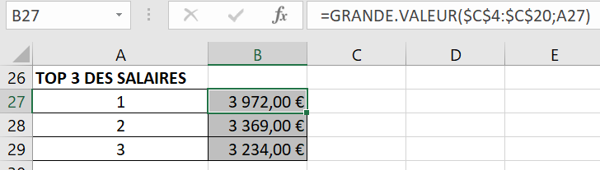

- Exercise S1.3: Basic calculation tools
Using Exercise S1.3, instructors will use this file to complete the grey cells and explain the basic calculation tools.
A completed version of this exercise is available for instructors: Exercise S1.3 - Answer key
- In column D: calculate a percentage change.

- Application exercise – The Food Truck
Using The Food Truck file, students will apply the concepts covered earlier in the session. A completed file, The Food Truck – Answer key, is available.
It is strongly recommended to give students 20 minutes to complete the exercise and reserve 15 minutes for a whole-class correction.
- Session 1 – Worksheet 1:
The objective is to complete the columns: % distribution and % change.
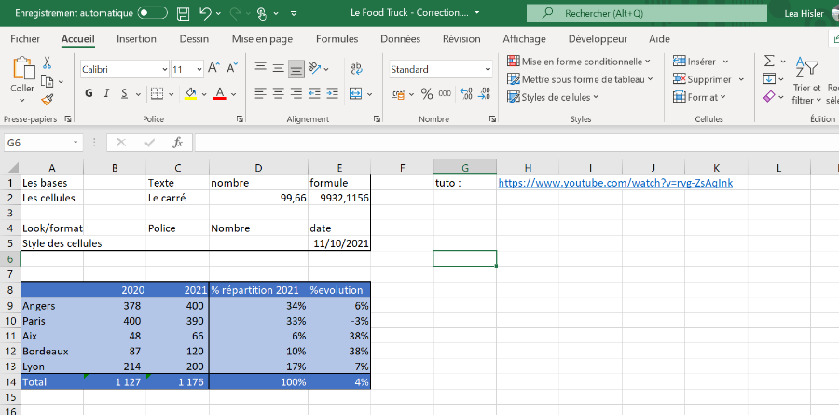

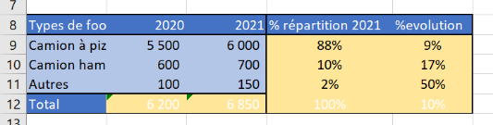

- Session 1 – Worksheet 2:
The first objective is to complete columns G to L in the orange table.
The second objective is to complete the orange summary.

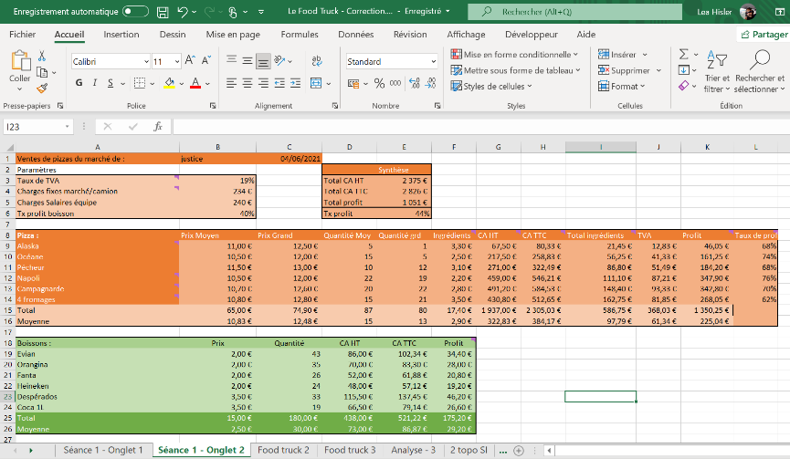

The third objective is to complete the green table: columns D, E, and F.
Note: It is useful to demonstrate to students that they can vary the parameters and observe how the results change.
Take a BREAK!
Session materials:
- Word teaching guide: Excel Fundamentals S1
- Block 1 - Exercise S1.4: Excel file (to be given to students)
- Block 1 - Exercise S1.4 - Answer key: Excel file (to be given to instructors)
- Block 1 - Exercise S1.5: Excel file (to be given to students)
- Block 1 - Exercise S1.5 - Answer key: Excel file (to be given to instructors)
- Block 1 - Exercise S1.6: Excel file (to be given to students)
- Block 1 - Exercise S1.6: Answer key: Excel file (to be given to instructors)
- The Food Truck: Main Excel case-study file
- The Food Truck – Answer key

- Exercise S1.4: Introduction to the IF function
Using Exercise S1.4, instructors will use this file to complete the grey cells and explain the IF function.
A completed version of this exercise is available for instructors: Exercise S1.4 - Answer key
- In column C: write "TOO COLD" when the temperature is strictly below 4°.
- In column D: write "TOO COLD" when the temperature is strictly below 4°, "OK" when the temperature is between 4° and 6°, and "TOO HOT" when the temperature is above 6°.

- Exercise S1.5: Application exercise on the IF function
Using Exercise S1.5, students will apply the concept covered previously.
A completed version of this exercise is available for instructors: Exercise S1.5 - Answer key
- In column D, using the IF function: calculate the bonus corresponding to 5% of the additional revenue generated above the target.

- Exercise S1.6: AND/OR functions
Using Exercise S1.6, instructors will use this file to complete the grey cells and explain the two logical functions: AND and OR.
A completed version of this exercise is available for instructors: Exercise S1.6 – Answer key
For your employees to receive a €500 bonus, the following three conditions must be met:
- the employee must have more than 8 years of service
- their score must be at least 12
- the recorded number of late arrivals must be zero

In column E, all three conditions must be met.
In column F, AT LEAST one of these three conditions must be met.

- Application exercises – The Food Truck (45 min)
Using The Food Truck file, students will apply the concepts covered earlier in the session. A completed file, The Food Truck – Answer key, is available.
It is strongly recommended to give students 20 minutes to complete the exercise and reserve 15 minutes for a whole-class correction.
- Session 2 – Worksheet 1:
The first objective is to write "very good" in cell I3 if you have understood correctly; otherwise, write "we need to change the teacher".
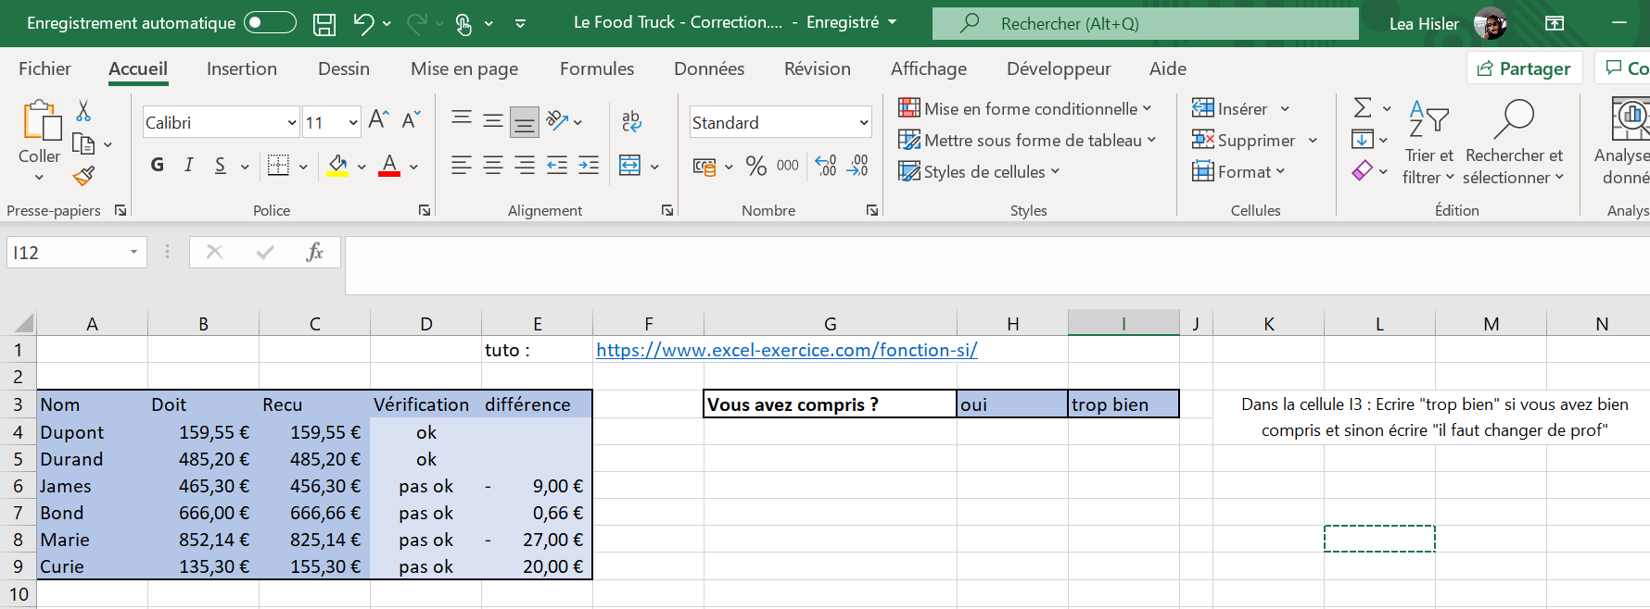
The second objective is to complete columns D and E:
In column D, using the IF function: check whether what was received matches what the person owed. If it is equal, write "ok"; otherwise, write "not ok".
In column E, using the IF function: if the check is not OK, calculate the difference.
- Session 2 – Worksheet 2:
The objective is to complete this invoice sheet using only the IF FUNCTION and basic calculations.
It is recommended to give students 20 minutes to complete this sheet and allow 15 minutes for the correction.
